**Consultation Survey on   
MSAC Application 1724**

**Cardiac technical support services provided by industry employed allied health professionals**

MSAC welcomes feedback on MSAC applications for public funding from individuals, organisations representing health professionals or consumers and/or carers, and from other stakeholders. Please use this template to prepare your feedback. You may also attach additional information if you consider it may be useful in informing MSAC and its sub-committees.

Sharing consultation feedback

Submitted consultation feedback will be shared with the Applicant and with MSAC and its sub-committees.

* The applicant will receive a summary of comments from individuals, with the individual’s name and other identifying information removed.
* MSAC and its sub-committees will receive both the summary and copies of the comments, with the name of the individual and other identifying information removed.
* Consultation feedback from groups or organisations will be provided in a complete form to both the Applicant and to MSAC and its sub-committees.

Please do not include information in your feedback that you do not want shared as outlined above. In addition, to protect privacy, do not include identifying personal (e.g. name) or sensitive (e.g. medical history) information about third parties, such as medical professionals or friends/relatives.

How consultation feedback is used

MSAC and its sub-committees consider consultation feedback when appraising an application, including to better understand the potential impact of the proposed medical technology/service on consumers, carers, and health professionals. A summary of consultation feedback will be included in the Public Summary Document (PSD) published on the MSAC website once MSAC has completed its appraisal. The PSD may also cite feedback from groups/organisations, including the name of the organisation. As such, organisations should not include information or opinions in their feedback that they would not wish to see in the public domain.

Consultation deadlines.

Please ensure that feedback is submitted by the pre-PASC or pre-MSAC consultation deadline for this application. Consultation deadlines for each PASC and MSAC meeting are listed in the PASC and MSAC and ESC calendars available on the [MSAC website](http://www.msac.gov.au/internet/msac/publishing.nsf/Content/Home-1). They are also published in the MSAC Bulletin. Feedback received after the respective deadlines may not be considered.

For further information on the MSAC consultation process please refer to the MSAC Website or contact the Consumer Evidence and Engagement Unit on email: [commentsMSAC@health.gov.au](mailto:commentsMSAC@health.gov.au).

Thank you for taking the time to provide your feedback. Please return your completed survey to:

**Email**: [commentsMSAC@health.gov.au](mailto:commentsMSAC@health.gov.au)

**Mail:** MSAC Secretariat,

MDP 960, GPO Box 9848,

ACT 2601

# PART 1 – PERSONAL AND ORGANISATIONAL INFORMATION

1. **Respondent details**

Name: Ben Harris

Email: ben.harris@pha.org.au

Phone No: (02) 6202 1000

1. Is the feedback being provided on an individual basis or by a collective group?

**Collective Group**

**If a collective group, specify the name of the group**

Private Healthcare Australia

1. How would you best identify yourself?

**Other**

If other, please specify

Payor representative

# PART 2 – CLINICAL NEED AND PUBLIC HEALTH SIGNIFICANCE

1. Describe your experience with the medical condition (disease) and/or proposed intervention and/or service relating to the application form

Private Health insurers are the major funders of CIEDs implanted annually. Over 16,000 of these devices a year are funded through the private system.

1. What do you see as the benefit(s) of the proposed medical service, in particular for the person involved and/or their family and carers?

The service has value, which is why is already paid for through other mechanisms.

While the service is already paid for through other mechanisms, CIEDs in the Australian private system attract the world’s highest prices – and more than double the public sector price.

An expert committee only two years ago found 97% of the services describing in this application were already funded or could be performed by remote monitoring now charged to near 100% of patients leaving hospital.

The government’s Cardiac Industry Working Group report (2020) clearly stated:

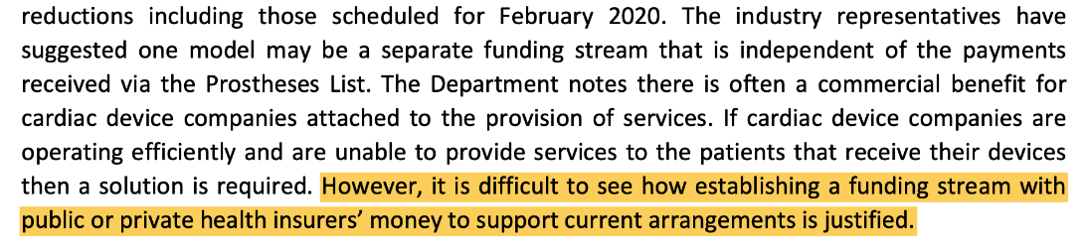

Moreover, the report recognised this model of service provided by the Device Industry was consistent the world over and was not funded through additional payment:

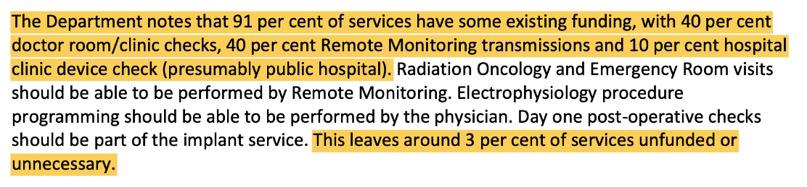

The MTAA’s claim states that the expert group did not provide any recommendations on a funding mechanism is misleading, the report clearly noted that the services were already funded.

Private Health Insurers already fund Remote Monitoring Services, with a current benefit of $1450 paid for either the monitor or the equivalent software.

MSAC/MBS 1197 resulted in funding for remote monitoring services by clinicians and Remote Monitoring funded through the Prostheses List. Consumers currently pay over $28 million a year for these services through their private health insurance premiums.

Cardiac companies are paid-up front whether the service is delivered or not. The Cardiac IWG noted;

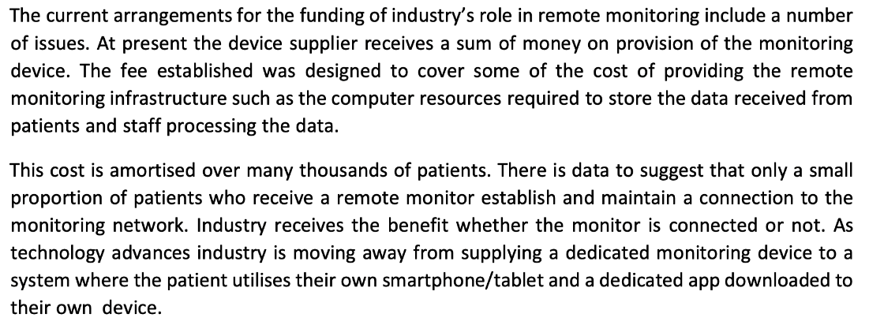

While four payments streams are proposed by the MTAA in their submission, the preferred option is an upfront payment levied against private insurers via the Prostheses List, in addition to the current funding streams:

- remote monitors through the Prostheses List

- additional costs on the primary devices (currently more than double the public price, yet proposed to remain 20% higher than the public price), and

- MBS payments for clinicians’ services.

This new proposal is double/triple dipping and should be rejected.

1. What do you see as the disadvantage(s) of the proposed medical service, in particular for the person involved and/or their family and carers?

There are many downside effects of this proposal, again largely called out in the Cardiac Industry Working Group report. The key disadvantage is that any additional payments would be inflationary (adding cost with no additional service).

Second, there is commercial advantage for device companies in providing this service – which is why consumers can currently be [signed up for the service for free on-line](https://www.medtronic.com/au-en/patients/treatments-therapies/remote-monitoring/follow-your-heart.html#:~:text=With%20the%20Medtronic%20app%20connected%20pacemakers%2C%20you%20can%20securely%20access,if%20anything%20unexpected%20should%20happen.).

Third, the services are explicitly funded through the support of a monitor or monitoring software on the Prostheses List (see MSAC/MBS 1197), with a current benefit of $1450. Many of these monitors are not used – the MBS data suggest actual usage of these devices at 10-20%, with MTAA suggesting around 80% usage.

The Cardiac IWG report also notes that device company representatives supporting clinicians is a standard practice in Australia across almost every surgical discipline. As the Cardiac IWG stated any funding stream of device company representatives doing their jobs would create a precedent for all other reps to be paid to do the job that clinicians and nursing staff are already funded to do. All the evidence suggests device company representatives supporting cases is the norm globally – this is not a unique need in Australia.

The Cardiac IWG went on to describe how companies all have external check devices (universal controllers), that can be provided to the cardiologist or hospital to do these checks. Instead of providing these low-cost one off items that would avoid the need to attend these checks and could be used on all patients by that clinician, the companies are focused on sending their staff out to these checks to ensure their marketing presence.

The MTAA submission notes that they were asked to put this proposal to MSAC as part of the Memorandum of Understanding between the previous Minister and the multinational device companies (the MoU). The application also seeks to redefine the task to determine the total value of the services, rather than the added value of the services.

The MoU provided a delay in benefit reductions to allow for MSAC deliberations on the value of the technical support services. Overall, this delay contributes to over $300 million more for CIEDs consumers will be required to pay than the same devices in the public sector over four years. The MoU allows for a final price including a 20% surcharge on all CIEDs for private patients above the public sector prices for these devices.

The application seeks a further payment on top of this 20% surcharge, which was put in place to account for the services provided by sponsors in addition to any services provided to the public sector. MSAC may wish to consider why private patients are required to pay double the public price for CIEDs this year and next, and 20% more than the public price in year four of the MTAA MoU; and why MSAC should grant additional funding on top of the existing surcharge.

CIEDs in the private sector are more than twice as expensive as the same devices in the public sector, per IHACPA data. Even the public sector prices are high compared to international benchmarks. A February 2022 review conducted by Evaluate[1] (supplied) in partnerships with XMEDiQ (Europe) and Discovery Health South Africa found the four leading (HCP1 volume) Dual Camber Pacemakers from Medtronic, Abbott, Boston and Biotronik were sold at multiples on the Private Health System (PL) over the average price of the exact same code across 8 comparable International markets across Europe, South Africa and NZ.



The costs of the devices are excessive.

The amount of funding being sought in the application for support services also seems excessive. The Cardiac IWG review, utiliising data provided by the MTAA and the Department, found on average between 1 and 2 patient contacts of cardiac services are provided per year per patient, with an average of 1.4. CIEDs routinely have a maximum 10-year life expectancy (with a lower average given replacements and deaths). The MTAA data showed was that the most common place where services were provided were in outpatient clinics (annual checks) where it is likely 10+ people would have their readings checked over the space of 60-90 minutes.

The services described seem to equate to an average 14 x 6 minute patient investigations over the life of the device. Yet the application suggests costs in excess of $100 million per annum for these services. The economic analysis provided suggests that the surgeon and rep drive all the way to a hospital to do one check and then go home calculating all the hours taken as one incident. More likely is that the specialist allocates a set period each week, to perform annual or bi-annual device checks depending on the patient’s history which involves a number of patients per session. There are benefits of scale that are not accounted for, putting aside the fact that the services are already funded.

PHA has no concerns about the qualifications of staff undertaking these assessments, but notes that the qualifications of many do not meet common definitions of allied health professionals.

1. What other benefits can you see from having this intervention publically funded?

Nil.

1. What other services do you believe need to be delivered before or after this intervention, eg Dietician, Pathology etc?

n/a

# PART 3 – INDICATION(S) FOR THE PROPOSED MEDICAL SERVICE AND CLINICAL CLAIM

1. Do you agree or disagree with the proposed population(s) for the proposed medical service as specified in Part 6a of the application form?

**Strongly Disagree**

Specify why or why not:

n/a

1. Have all the associated interventions been adequately captured in Part 6b of the application form?

**No**

Please explain:

As noted, 97% of all services have already been determined to have a funding stream attached paid for by taxpayers and Private Health Insurers – the application is a claim for duplicate funding.

1. Do you agree or disagree that the comparator(s) to the proposed medical service as specified in Part 6c of the application form?

**Strongly Disagree**

Please explain:

The comparators include the existing funding streams which already cover 97% of the nominated services, and the surcharges on the primary CIED items.

1. Do you agree or disagree with the clinical claim made for the proposed medical service as specified in Part 6d of the application form?

**Strongly Disagree**

Specify why or why not:

The services are valued, which is why they are currently funded.

# PART 4 – COST INFORMATION FOR THE PROPOSED MEDICAL SERVICE

1. Do you agree with the proposed service descriptor? MSAC is transitioning to new application forms so the relevant question in the application form will vary depending on the version used. For medical services on the MBS, see question 51 or 53. For medical services seeking funding from a source other than the MBS, see question 52 (new application forms only—labelled v. 2.5).

**Strongly Disagree**

Specify why or why not:

n/a

1. Do you agree with the proposed service fee? MSAC is transitioning to new application forms, so the relevant question in the application form will vary depending on the version used. For medical services on the MBS, see question 51 or 53. For medical services seeking funding from a source other than the MBS, see question 52 (new application forms only—labelled v. 2.5).

**Strongly Disagree**

Specify why or why not:

There is no service fee proposed. All that is provided is a reference to a review which contradicts the findings of the expert committee from the Cardiac IWG which examined these issues two years ago.

The MBS provides a benefit for performing this check of $55.30 (MBS 11721), yet the application appears to argue that the technicians’ time is more valuable.

**PART 5 – ADDITIONAL COMMENTS**

1. Do you have any additional comments on the proposed intervention and/or medical condition (disease) relating to the proposed medical service?

PHA is yet to be told why people with private health insurance should be paying a 20% surcharge for CIEDs above prices paid by public patients for these devices. PHA would welcome MSAC advising government on the HTA value of this surcharge.

1. Do you have any comments on this feedback survey? Please provide comments or suggestions on how this process could be improved.

Nil comment.

1. Furnival A, et.al *“Price comparison of the Australian Private Prostheses List with 8 international markets”* 22/2/22